**Using PEST with EPA SWMM**

Michelle Simon and Faryn Dumont

December 2021

Abstract

USEPA’s Stormwater Management Model (SWMM) is a widely used hydraulic and hydrologic model for predicting flows of stormwater and wastewater. SWMM has many empirical relationships, especially the Manning equation coefficient, which can be determined by adjusting model parameters to have model results match observed data. PEST is a software package and a suite of utility programs to optimize the parameter estimation process. The steps for utilizing PEST for SWMM calibration is outlined in this document.

Introduction

SWMM <https://www.epa.gov/water-research/storm-water-management-model-swmm>

PEST <https://pesthomepage.org/> PEST, parameter estimation program, widely used. Talk about how PEST is in FORTRAN, calls up input files, adjusts specific parameter values, and recalculates results to have closest predictions. the M-L process Least squares algorithm

While there have been several successful published studies that used PEST with SW<<: References (Ekmekcioglu, Yilmaz et al. , Ovbiebo and Kuch 1998, Lin, Simon et al. 2018, Zhu, Chen et al. 2019, Perin, Trigatti et al. 2020, Platz, Simon et al. 2020, Koc, Ekmekcioglu et al. 2021). There have been many questions on using PEST with SWMM <https://www.openswmm.org/Topic/10031/pest-customization-with-swmm> ; <https://www.openswmm.org/Home/Search?Query=PEST%20calibration%20SWMM&Research=false&UnansweredQuestions=true> .

It is somewhat non straight forward to use PEST for SWMM Parameter estimation, as the SWMM program’s output file (*.out) is in a binary file and SWMM’s report file (*.rpt) does not necessarily contain the output data necessary for PEST calibration. PEST requires an ASCII file. SWMMToolbox <https://pypi.org/project/swmmtoolbox/> is one open source utility to convert data from a SWMM binary file from the dot prompt.

This document is a practical guide on using PEST with SWMM and employs SWMM specific files. This work was inspired by Lin (~ 2018) <https://www.ndsu.edu/pubweb/~zhulin/pdf/teaching/starting%20pest.pdf> ) who created a short, clear, guide for using PEST with SWAT. As did Lin, we also do not imply that this document can replace the excellent documentation or training on PEST that is contained in (<https://pesthomepage.org/documentation>) and elsewhere.

This is a simple document for assisting a beginner getting started using PEST with a very simple SWMM example, citing the common file names for SWMM. We utilize an ASCII file produced by SWMM, an LIDReport.txt file, that can be generated by SWMM’s input file. In this Green Roof example, SWMM generates an ASCII output file which can been directly accessed by PEST. Our assembled instructions closely follow the steps outlined in Chapter 18 in *“PEST, Model-Independent Parameter Estimation User Manual Part I: PEST, SENSAN, and Global Optimisers.”* (Doherty 2020) but lists SWMM specific files.

In this simple example, we have a Green Roof SWMM 5.1.015 input file (greenroof.inp) which generates a SWMM Report file (greenroof.rpt), GreenRoof.txt LID Report file (Greenroof.txt). Bu following the steps below, you will generate a PEST template file (greenroof.tp), Instruction File (greenroof.ins), and Observation File (greenroof.obj). You also need to path or include SWMM5.dll and SWMM5.exe in the working folder.

There are 132 observed vales for drainflow for this SWMM + PEST example. The paraemeter that is adjusted in the initial saturation for the initial saturation for the Green Rood LID. The symbol for PEST is “#).

PEST will use pestgen to generate a PEST file (greenroof.pst) and checks the template, instruction, and pest files with the tempchek, inschek, and pestchek utilities distributed with PEST.

As you follow through this example, PEST will overwrite necessary files. We recommend that you back a backup copy of the EXAMPLE files in case you inadvertently overwrite a working PEST file.

Steps:

1. Download and path PEST, if you have not down so already:

You can download PEST <https://pesthomepage.org/programs> .

When we started we followed the surface water (sw) example, which used the Hydrologic Simulation Program – Fortran (HSPF)( <https://www.epa.gov/ceam/hydrological-simulation-program-fortran-hspf> ) in provided in the PEST Tutorial. An even more simple is the TWOLINE FORTRAN Program, present in Chapter 18 of the PEST User’s Manual, which we followed here. The TWOLIN FORTRAN example files are located in the pestex folder downloaded with PEST.

We recommend making a backup copy of the EXAMPLE folder as PEST will be overwriting working files.

We placed PEST in the C: drive and synced it with our online directory. We also pathed PEST in the environmental variables location in the System Properties editor. The easiest way to path PEST is to type “env” in the Windows search option at the bottom of the Windows page (<https://www.architectryan.com/2018/08/31/how-to-change-environment-variables-on-windows-10/> ) . Please see the following three screen shots.

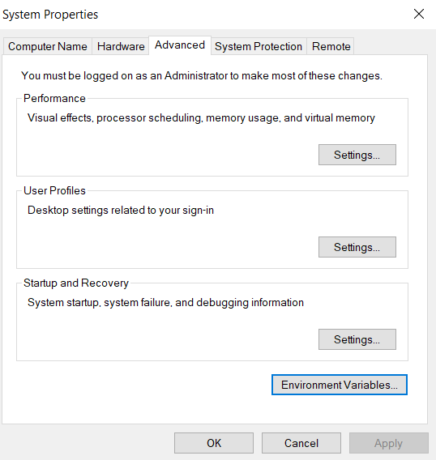

Figure 1

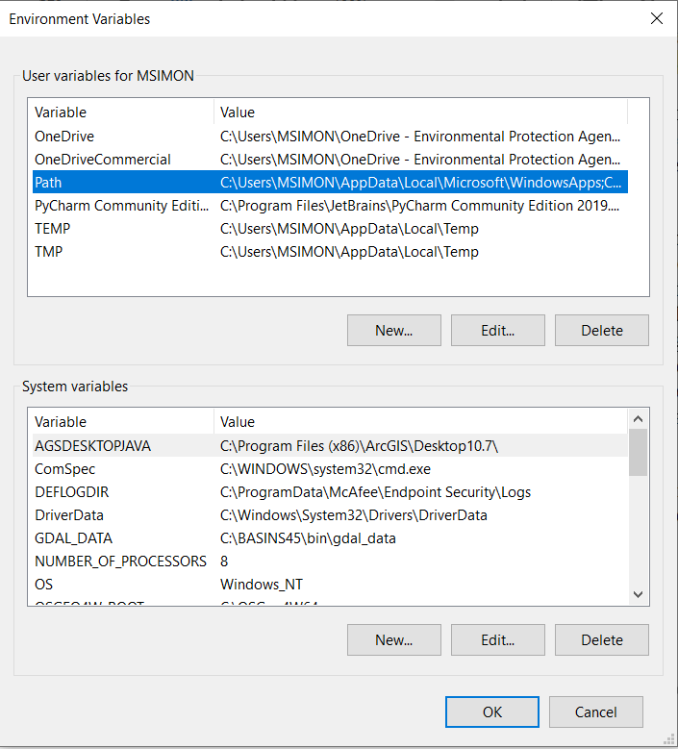

Figure 2 Redo to take MSIMON out of these screens

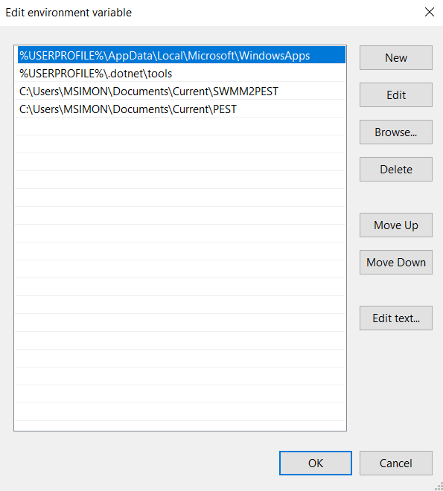33

Figure 3 redo remove MSIMON

You may also wish to apply the same method to path SWMM5.exe and SWMM5.dll or you can copy these files into your working directory.

Many people create a batch file to run SWMM5, see Figure 4.

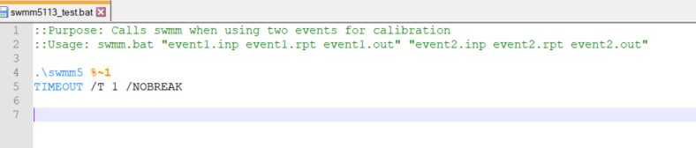

Figure 4 SWMM\PEST batch file, correct both the SWMM 5.1.015 files

When run at the dot prompt

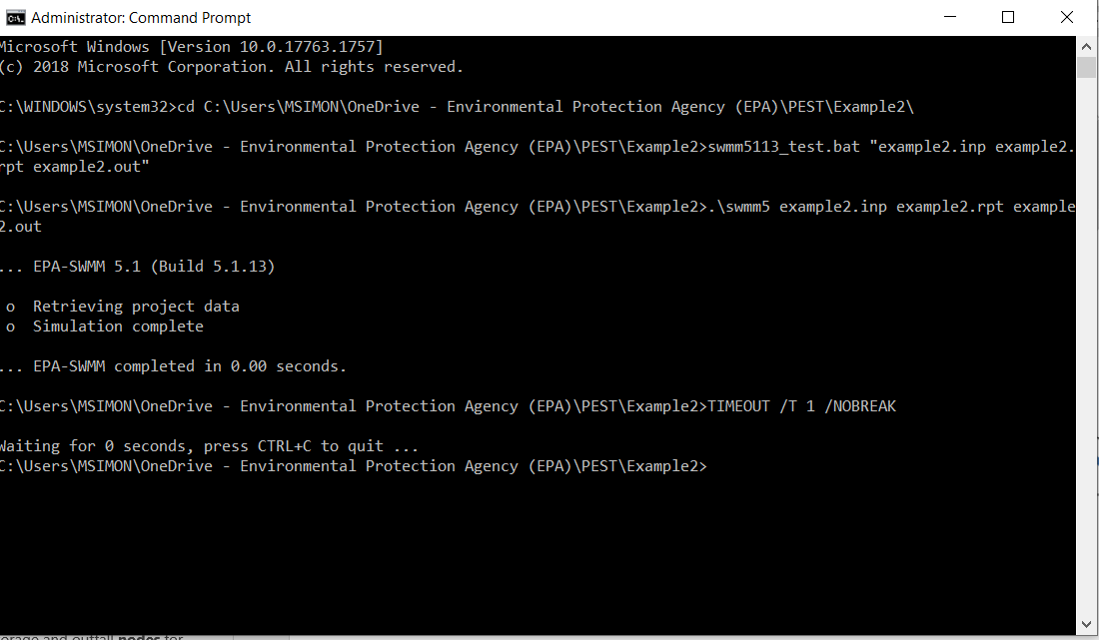

Figure 6 remove MSIMON

1. PEST requires these files to run

As stated earlier, we recommend making a backup copy of the EXAMPLE folder as PEST will be overwriting working files.

Here are the necessary files

1. Optional batch files greenroof.bat
2. Model input template files greenroof.tpl, run tempchek
3. Model output reading instruction files greenroof.ins, inschek, greenroof.obf columns are correct in notepad BUT NOT Notepad++
4. PEST control file SWMM5.pst, pestgen, pestchek

2.1 Generate a template file, based on inp.file, see section 18.1.3 in the PEST User’s Manual Part1.

In this example, we varied initial saturation of Green Roof LID of the subcatchment, we used Init_Sat from [LID_USAGE] page 295 of the User’s Manual.

Using a text editor, such as NotePad++, open the greenroof.inp and copy it into greenroof.tpl. Add ptf #See of greenroof.tpl file, # is the pst symbol.

The parameter to be adjusted in initial saturation #InitSat# in line 84. Save greenroof.tpl.

At the Dot Prompt > tempchek greenroof.tpl. See the PEST Manual for explanation of any errors should any appear.

Pest will create a file called greenroof.pmt. Using Notepadd++, create a file call greenroof.par

>tempchek greenroof.inp in.par

> swwm5 greenroof.inp greenroof.rpt greenroof.out

* 1. Creating Instruction Files, greenroof.ins, see section 18.1.4 the PEST User’s Manual Part1.

Open the LIDReport.txt file, greenroof.txtIn file greenroof.obj, there are 132 entries. Find in lid usage report, generate greenroof.ins file. Generate greenroof.obj file

Control File – master file greenroof.pst file

Use pestgen

Replace

Model command line

Model input/output

Prior information

Pestchek

Model command line

Model input/output

* model command line

SWMM5 greenroof.inp greenroof.rpt greenroof.out

* model input/output

greenroof.tpl  greenroof.inp

drnflow.ins  gr140.txt

Run pest > pest swmm5

PEST OUTPUT FILES

Run Record (.rec) see

Objective function history

Parameters history

Stats for residuals, groups, correlation

Residuals (.res)

Calculated and Observed values for observations (including weighted value)

Residuals

Sensitivities – Parameters (.sen)

Sensitivities – Observations (.seo)

Testing

Conclusions

Disclaimer

Acknowledgements – Colleen Barr

References

Getting Started with PEST and SWMM

SWAT <https://www.ndsu.edu/pubweb/~zhulin/pdf/teaching/starting%20pest.pdf>

HSPF <https://www.epa.gov/ceam/pest>

Modflow <http://swmm2000.com/forum/topics/swmm-calibration-using-pest>

Add OpenSWMM search on PEST and Calibration

<https://www.researchgate.net/publication/337846579_A_New_Tool_for_Automatic_Calibration_of_the_Storm_Water_Management_Model_SWMM>

<https://github.com/XuanyiLin/SWMM2PEST2.0>

PESTcommander

PEST Manual(2)

SWMM PEST References

PEST Book

YouTube Videos

**Model-Independent Parameter Estimation,** User Manual Part I: **PEST, SENSAN and Global Optimisers,** *7th Edition published in 2018 Latest additions: Feb 2020* [*https://www.nrc.gov/docs/ML0923/ML092360221.pdf*](https://www.nrc.gov/docs/ML0923/ML092360221.pdf)

Getting started with PEST (2006) https://www.ndsu.edu/pubweb/~zhulin/pdf/teaching/starting%20pest.pdf

Training RMAPestNotes

Literature

Ekmekcioglu, O., et al. "Investigation of the low impact development strategies for highly urbanized area via auto-calibrated Storm Water Management Model (SWMM)." Water Science and Technology: 20.

This study aims to investigate the effectiveness of the low impact development (LID) practices on sustainable urban flood storm water management. We applied three LID techniques, i.e. green roof, permeable pavements and bioretention cells, on a highly urbanized watershed in Istanbul, Turkey. The EPA-SWMM was used as a hydrologic-hydraulic model and the model calibration was performed by the well-known Parameter ESTimation (PEST) tool. The rainfall-runoff events occurred between 2012 and 2020. A sensitivity analysis on the parameter selection was applied to reduce the computational cost. The Nash-Sutcliffe efficiency coefficient (NSE) was used as the objective function and it was calculated as 0.809 in the model calibration. The simulations were conducted for six different return periods of a storm event, i.e. 2, 5, 10, 25, 50 and 100-years, in which the synthetic storm event hyetographs were produced by means of the alternating block method. The results revealed that the combination of green roof and permeable pavements have the major impact on both the peak flood reduction and the runoff volume reduction compared to the single LIDs. The maximum runoff reduction percentage was obtained as 56.02% for a 10-years return period of a storm event in the combination scenario.

Koc, K., et al. (2021). "An integrated framework for the comprehensive evaluation of low impact development strategies." Journal of Environmental Management **294**: 18.

The impacts of urbanization on water quality, hydrology, society, and the environment can be minimized through low impact development (LID) practices in urban areas. This study has evaluated the performances of seven different LID scenarios including stand-alone and different combinations of green roof (GR), bioretention cells (BC), permeable pavement (PP), and infiltration trench (IT) in the Ayamama watershed, which is one of the most densely urbanized areas in Istanbul. Stormwater Management Model (SWMM) was used to obtain the performances of LID scenarios in quantitative (i.e., volume reduction and peak runoff reduction) and qualitative (i.e., Total Suspended Sediment, Chemical Oxygen Demand, Total Nitrate, Total Phosphate reductions) manner. To calibrate the SWMM model, the Parameter EStimation Tool (PEST) was integrated for sensitivity analysis and parameter optimization. A focus group discussion (FGD) was performed to identify the criteria and LID scenarios applicable to the study area. 16 criteria were determined as suitable, based on three dimensions of sustainability such as social, economic, and environmental. The criteria were evaluated in compliance with the fuzzy analytical hierarchy process (AHP) method before performing technique for order preference by similarity to ideal solution (TOPSIS) for a comprehensive assessment of LID scenarios. The results showed that community resistance, operation feasibility, and quantitative benefits were the most significant criteria for LID scenario selection in social, economic, and environmental aspects, respectively. The integrated evaluation showed that the impacts of urban flooding can be reduced significantly with the combination of GR and BC. Thus, this study provides an integrated and sustainable solution to the topic based on the PEST-SWMM-fuzzy AHP-TOPSIS framework. Furthermore, the developed framework could assist decision-makers and governmental authorities to designate optimal LID scenarios.

Lin, X. Y., et al. (2018). Hierarchical Metamorphic Relations for Testing Scientific Software. 13th IEEE/ACM International Workshop on Software Engineering for Science (SE4Science), Gothenburg, SWEDEN, Ieee.

Scientist developers have not yet routinely adopted systematic testing techniques to assure software quality. A key challenge is the oracle problem, a situation in which appropriate mechanisms are unavailable for checking if the code produces the expected output when executed using a set of test cases (TCs). Metamorphic testing alleviates the oracle problem by specifying the relationship that a source TC and its follow-up TC shall meet. Such relationships are called metamorphic relations (MRs) which are necessary properties of the intended program's functionality. Existing approaches handle the MRs in a flat manner. This paper introduces a novel way to facilitate a hierarchy of MRs to be developed incrementally. We illustrate our approach by testing U.S. EPA's Storm Water Management Model (SWMM). The results offer concrete insights into developing effective MRs to systematically test scientific software.

Ovbiebo, T. and A. W. Kuch (1998). Non-linear parameter estimation of an urban runoff model using XP-SWMM32 and PEST. Special Session of ASCE 25th Annual Conference on Water Resources Planning and Management / 1998 Annual Conference on Environmental Engineering, Chicago, Il, Amer Soc Civil Engineers.

This paper presents a case study of utilizing XP-SWMM32's Automatic Calibration module to calibrate an urban runoff model. In this study a $1.5 million Capital Improvement Project in the Lake City drainage basin is evaluated using the XP-SWMM32 stormwater model. Using the software tools the SWMM model is reliably calibrated in a shorter time than would have been possible using the typical manual, trial and error approach. The software tools presented in this paper allow the modeler to concentrate on initial data preparation and reasonable parameter hounds rather than on tedious model adjustment. At the core of the Automatic Calibration module is a parameter optimization software program PEST (an acronym for Parameter ESTimation). The calibration software utilizes the models own input and output files and automates the creation of the control files for calibration. The model is calibrated to a multiple storm rainfall event with a duration of two days. Pre-calibration and post calibration plots of computed versus observed hydrographs are presented. The verification by substituting the calibrated parameter set to three other similar events is shown using a comparative plot of ail hydrograph peak flows.

Perin, R., et al. (2020). "Automated calibration of the EPA-SWMM model for a small suburban catchment using PEST: a case study." Environmental Monitoring and Assessment **192**(6): 17.

Rainfall-runoff models must be calibrated and validated before they can be used for urban stormwater management. Manual calibration is very difficult and time-consuming due to the large number of model parameters that must be estimated concurrently. Automatic calibration offers as a promising alternative, ideally supporting a user-independent and time-efficient approach to model parameters estimation. In this article, we test the use of a state-of-the-art standard package (PEST, Parameter ESTimation, ) for the automatic calibration of a rainfall-runoff EPA-SWMM (Storm Water Management Model) model developed for a small suburban catchment. Results reported in the paper demonstrate that the performance of automatically calibrated models still depends on a number of user-dependent choices (the level of catchment discretization, the selection of significant parameters, the optimization techniques adopted). Through a systematic analysis of the results, we try to identify the guidelines for the effective use of automatic calibration procedures based on modeling assumptions and target of the analysis.

Platz, M., et al. (2020). "Testing of the Storm Water Management Model Low Impact Development Modules." Journal of the American Water Resources Association **56**(2): 283-296.

Stormwater infrastructure designers and operators rely heavily on the United States Environmental Protection Agency's Storm Water Management Model (SWMM) to simulate stormwater and wastewater infrastructure performance. Since its inception in the late 1970s, improvements and extensions have been tested and evaluated rigorously to verify the accuracy of the model. As a continuation of this progress, the main objective of this study was to quantify how accurately SWMM simulates the hydrologic activity of low impact development (LID) storm control measures. Model performance was evaluated by quantitatively comparing empirical data to model results using a multievent, multiobjective calibration method. The calibration methodology utilized the PEST software, a Parameter ESTimation tool, to determine unmeasured hydrologic parameters for SWMM's LID modules. The calibrated LID modules' Nash-Sutcliffe efficiencies averaged 0.81; average percent bias (PBIAS) -9%; average ratio of root mean square error to standard deviation of measured values 0.485; average index of agreement 0.94; and the average volume error, simulated vs. observed, was +9%. SWMM accurately predicted the timing of peak flows, but usually underestimated their magnitudes by 10%. The average volume reduction, measured outflow volume divided by inflow volume, was 48%. We had more difficulty in calibrating one study, an infiltration trench, which identified a significant limitation of the current version of the SWMM LID module; it cannot simulate lateral exfiltration of water out of the storage layers of a LID storm control measure. This limitation is especially severe for a deep LIDs, such as infiltration trenches. Nevertheless, SWMM satisfactorily simulated the hydrologic performance of eight of the nine LID practices.

Zhu, Z. H., et al. (2019). "An assessment of the hydrologic effectiveness of low impact development (LID) practices for managing runoff with different objectives." Journal of Environmental Management **231**: 504-514.

This study represents an approach to assess the hydrologic effectiveness of low impact development (LID) practices based on the expected runoff process with different objectives and land utilization. The proposed approach is to simulate runoff hydrograph rather than several indices (e.g., runoff initiation, peak flow, and runoff volume) to avoid the uncertainties under a certain rainfall scenario. A rainfall-runoff model of a residential district in China, constructed based on the stormwater management model (SWMM), is auto-calibrated (validated) based on 12 (25) observed rainfall and runoff events using model-independent parameter estimation (PEST). The priority sites and parameters for LID practices for different objectives are auto-calculated using PEST based on the calibrated model and different expected runoff processes. The expected runoff processes are simulated from the calibrated model with four impervious cover scenarios corresponding to 5-year, 2-h duration design storm. The study illustrates that (i) the proposed approach can auto-optimize runoff manage strategies based on LID practices and land; (ii) the design parameters of LID practices can be auto-calculated and that simulated runoff processes are in near perfect agreement with expected runoff processes; (iii) this approach can auto-optimize any specific parameters of the SWMM and LID practices without changing those determined parameters. Our simple, but quantitative, approach for identifying potential LID sites and design parameters based on land can better inform the hydrologic effectiveness of LID practices for managing runoff.